Dell risers configuration:
https://www.dell.com/support/manuals/en-au/poweredge-r740/per740_techspecs_pub/expansion-bus-specifications?guid=guid-980ac5b8-ef7d-4759-8956-82c2aba9002a&lang=en-us

R740 (example risers and slots)
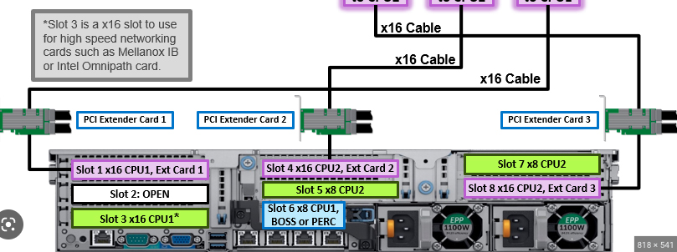

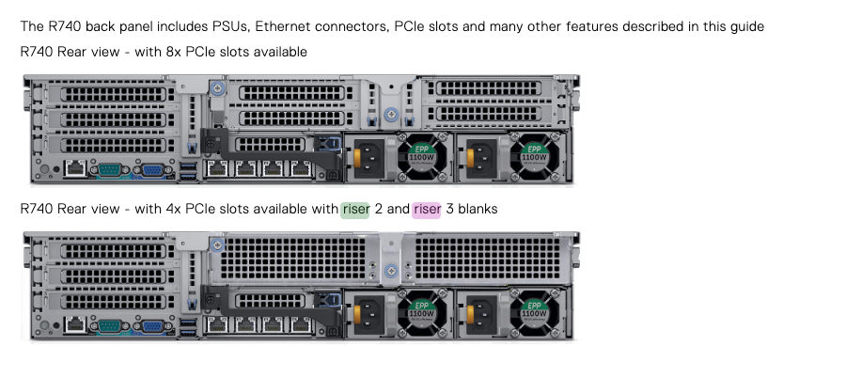

Example riser card board

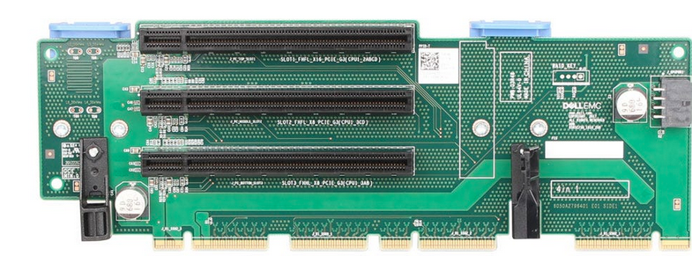

https://i.dell.com/sites/csdocuments/Shared-Content_data-Sheets_Documents/en/aa/PowerEdge_R740_R740xd_Technical_Guide.pdf

Broadcom: 57508 Dual Port 100GbE QSFP Adapter, PCIe 540-BDED
https://www.dell.com/en-hk/shop/broadcom-57508-dual-port-100gbe-qsfp-adapter-pcie-low-profile/apd/540-bdee/networking#tabs_section
The BCM957508-P2100G NIC is a PCI Express 4.0 x16
PCIe is a high-bandwidth serial bus providing a low pin-count interface as an alternative to parallel PCI. It is part of the host
interface connector.
I can be installed in riser 1 pci 3

