Dell risers configuration:
https://www.dell.com/support/manuals/en-au/poweredge-r740/per740_techspecs_pub/expansion-bus-specifications?guid=guid-980ac5b8-ef7d-4759-8956-82c2aba9002a&lang=en-us

R740 (example risers and slots)
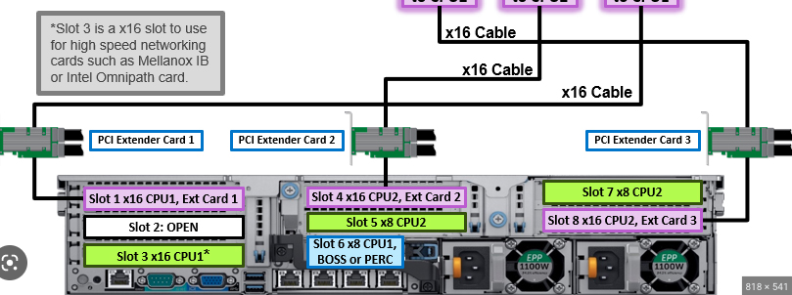

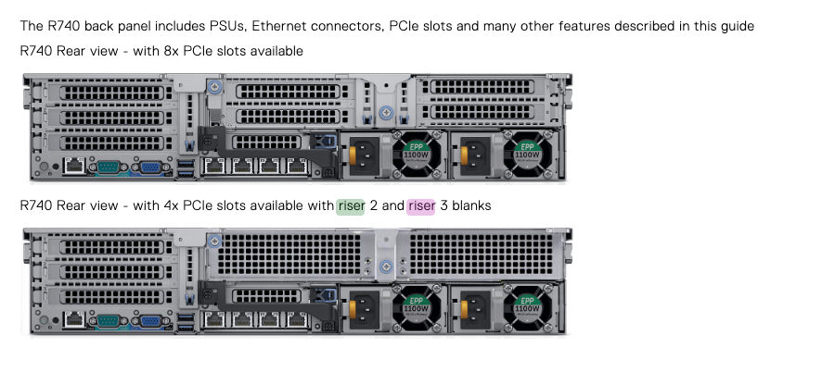

Example riser card board

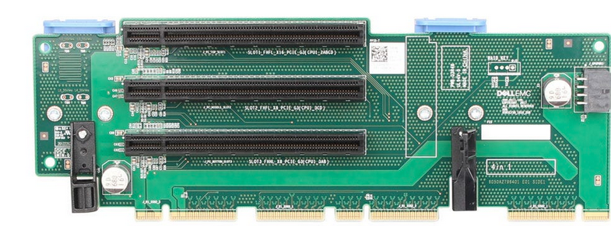

https://i.dell.com/sites/csdocuments/Shared-Content_data-Sheets_Documents/en/aa/PowerEdge_R740_R740xd_Technical_Guide.pdf

Broadcom: 57508 Dual Port 100GbE QSFP Adapter, PCIe 540-BDED
https://www.dell.com/en-hk/shop/broadcom-57508-dual-port-100gbe-qsfp-adapter-pcie-low-profile/apd/540-bdee/networking#tabs_section
The BCM957508-P2100G NIC is a PCI Express 4.0 x16
PCIe is a high-bandwidth serial bus providing a low pin-count interface as an alternative to parallel PCI. It is part of the host
interface connector.

PROCEDURE (from Dell):

DPN | Agile Description | Supplier | Category | Card Priority | Slot Priority | Bracket Height Allowed | Max # of Cards
DPNHJ | ASSY,CRD,CTL,H740P,8GB,ADPT | Dell | PERC 10: Internal Adapter | 4100 | 6,5 | FH or LP | 1
FPM6F | CRD,NTWK,BCME,FH,100G,2P,Q28 | Broadcom | NIC: 100G | 6700 | 1,8,4 | FH | 3
2 numbers to understand. Card priority and slot priority.
Card priority is the lower the number the more priority is given to this card. You can see that the H740P gets priority over the Broadcom NIC in your server config. So the PERC get seated its its optimised slot of slot 6.
Then the Broadcom card will be seated in its priority slot of slot 1
These factory default choices are mostly thermal and getting x16 cards in x16 slots

Location | Width | Length | Height | RSR1D | RSR2A |  | RSR3A
Agile p/n |  |  |  | GHGTP | T20VP |  | NMHT7
PCIe Slot-1 | DW | FL | FH | x16
PCIe Slot-2 | SW | FL | FH | x8
PCIe Slot-3 | SW | HL | FH | x8
PCIe Slot-4 | DW | FL | FH |  |  | x16
PCIe Slot-5 | SW | FL | FH |  |  | x8
PCIe Slot-6 | SW | HL | LP |  | x8
PCIe Slot-7 | SW | FL | FH |  |  |  | x8
PCIe Slot-8 | DW | FL | FH |  |  |  | x16
As you can see 1,8 & 4 are x16 slots. That’s why we`ll prioritise these for the Broadcom NIC.
So its gets the appropriate amount of lanes.
BTW, we`ll install the NICs. You`ll receive the full finished product unless you purposely buy any components in boxes.

